***INTRODUCTION***

Disabled people's organizations play many roles at the local, national and international levels for disabled people, governments, service providers and the general public. In many cases, the organizations of disabled people are the best vehicle to carry out the aspirations of people with disabilities. After all, disabled people, from their own personal experiences best know their needs, aspirations and abilities.

***WHAT WE DO?.............***

We provide families with emotional support, information, and direction.  When needed, we refer them to other agencies for additional services.  Our goal is to promote cooperation between families and schools to help kids succeed.

* ***Empowering Families to empower their children***
* We are assisting the Families of the Special Needs with education, advocacy, advice etc. that is supporting parents who have children with Special Needs.
* We have designed to provide programs such as Social Skills Training, Remedial reading etc., So there is no need to ask that such programs be created for your child.
* Because all the children have special needs, there is a better chance that your child will be socially accepted.

***COMPANY PROFILE***

* ***SERD ( ) is an Organization (an institution focused on specially needed children) registered under the enactment of social activities of the WESTERN Province –Sentence No., 7-by the No., SSD/G/bH/2011F08.***
* ***In addition, it was registered under the act of safeguarding the rights of specially needed children with the No.,/NSPD/R/167.***
* ***It is situated in Gampaha District in the Secretariat Division of Waragoda, at No.,519/4, 3rd Lane, Bonlandwatta.***
* ***It was inaugurated on 02nd Jan 2010 with only 9 children, but gradually the numbers of children has increased and for the time being 62 participants have registered within our institution.***

***Our Objectives***

The Objectives of the SERD are to:

* + Protect and promote the best interests and welfare of children and young persons and enable them to overcome social problems through economic empowerment of individuals, families and communities;
  + Assist the promotion of the family by reducing and mitigating the effects of disruption of relationships;
  + Promote, encourage, or assist any measures such as education,  skills-building, instruction, awareness and advocacy calculated to improve conditions of family life;
  + Establish, facilitate and/or assist temporary places of safety for children in need of care and protection;
  + Co-operate with government and organizations/persons with similar objectives.
  + Coordinate, collaborate and network with any other persons, governmental, non-governmental, and faith based organizations with special focus on identification, registration, tracing, as well as family and community reunification and reintegration of children in disaster, conflict and emergency situations and institutional care;
  + Ensure protection, care and development of child-headed families;
  + Promote foster care, guardianship and adoption as a last resort;
  + Improve the standard of living of children and their families by mobilizing and managing resources from income generating activities, donations from individuals, international and civil society organizations, governments, the business sector, and others;
  + Enter into arrangements with individuals, governments/authorities, public bodies, corporations, and companies that are conducive­ to the Society’s objectives in order to obtain any desirable rights, privileges and concessions;
  + Encourage community based reintegration of children;
  + Mainstream child rights approach in programming;.

***Our Vision***

***Our vision is to afford equal rights and opportunities to participate fully in his or her community with active and equal membership in society regardless of age or severity of impairment, disability of each and every child to be empowered to communicate his or her requirements and to make informed decisions about all of his or her life.***

***Our Mission***

Helping children (students) with Neuro development difficulties including Autism, Asperger’s AD/HD, verbal and non-verbal learning disorders reach their fullest potential

***Future Plan***

* Help children to make step to towards a brighter, happier future.
* To expand our duties and services up to 100 special needed children in the area. That is to build a guidance center for our children.
* To provide them the service of properly well-organized therapy center, with a recognized and well qualified staff.
* To establish under mentioned departments to train them in finding a suitable job, to earn something to live freely without depending on others in the society.

1. Weaving & tailoring division,
2. Candle making Unit,
3. A section for making wicks for oil lamps,
4. A department to paint & print clothes with modern equipment,
5. A paper making division & to create greeting cards etc. on different occasions,
6. An Industrial center for building blocks of cement, to use in building construction industry,
7. An official center to find out the necessity of the market on selling matters of productions of our children.

**MAIN ACTIVITIES IMPLEMENTED DURING LAST YEAR.**

1. **Maintained a nursery school to provide them with Pre-school Education.**
2. **Imparted them Special Education.**
3. **Conducted Programs of Physiotherapy, Speech Therapy & Occupational Therapy.**
4. **Conducted programs of Vocational Training.**
5. **Introduced programs on improving Aesthetic and Cultural concepts. (e.g. to improve talents on dancing & music ).**
6. **Organized sports & recreational programs.**
7. **Organized a broad range of Social Programs.**
8. **Maintained a Day Care Service.**
9. **Activated a number of additional special programs to improve their life conditions. (e.g. Help them to do their day to day activities by themselves without any help from others.)**

**Recently we have introduced Cookery Classes for them to improve their day to day activities.**

***Events***

**New Year Ceremony**

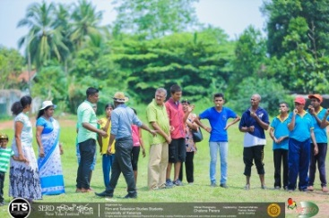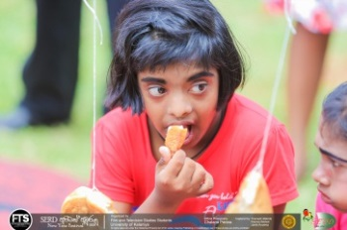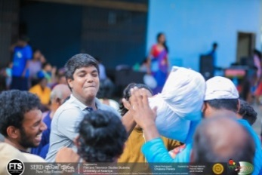

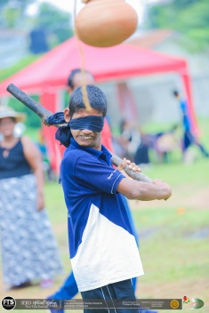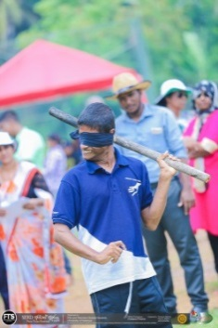

Hindu Sinhala New Year had celebrated this year,

on 28th Apr. 2018 . At this occasion the children of the following

Institutions have joined us and participated with their parents

and close relatives.

* The children and their parents of the ‘SERD’ organization,
* Children of ‘PREETHIPURA CHILDREN HOME’,
* Adults of the ‘PREETHIPURA ADULTS HOME’,
* Children of the ‘SUMAGA’ training centre

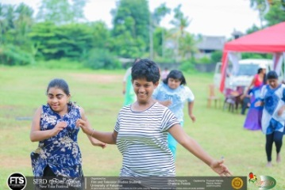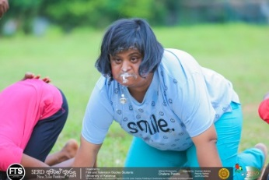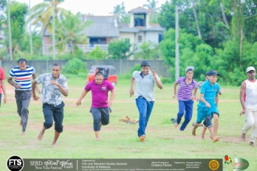

The New Year celebrating program was conducted and fully organized by the under

graduates (Girls and Boys) of the ‘University Of Kelaniya’,

And nearly 250 of them co-operate us in utmost support to bring the ceremony

a success.

In addition certain provincial organizations too have provided their full support

during this process.

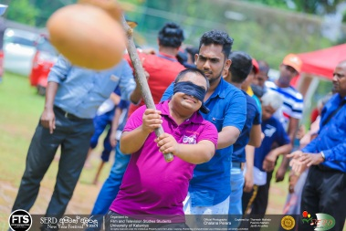

* Blindfold action in hitting the treasure pot

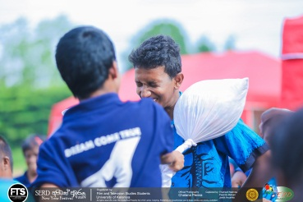

* pillow fighting really not an easy job

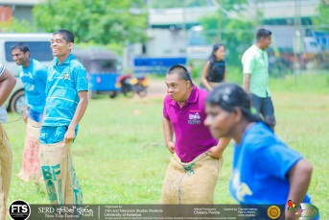

* Sack Races as an open event on the new year ceremony

**‘Vesak SIL PROGRAM’ & ‘DAN SALA’**

waiting in A Long Queue at ‘*Dan Sala’ hoping to*

*have cooked Manioc with a tastefull mouth of*

*‘pol Sambol’*

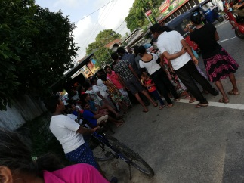

***People passing by Enjoying***

***A short-meal at the alms giving***

***Place (Dan Sala)***

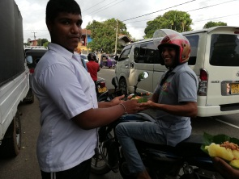

VESAK SIL PROGRAM was organized on the Vesak Poya day successfully by the children of our SERD Organization at

the college premises with more than 200 participants.

Among them were the parents, close relatives and a lot of well-wishers, and they mentioned that,

this ‘Sil Program ‘is one of the best that they observed in their life time.

All of them started to observe Sil at about 7 a.m. and the Sil campaign closed at about 3 p.m.

All the children and their parents with well-wishers had provided especial contribution on making

‘Dan Sala’ campaign a success.

This time ‘Cooked Manioc’ has been served and offered to about approximately 2000 people.

The arrangement of the Dan Sala’ program ended very successfully.

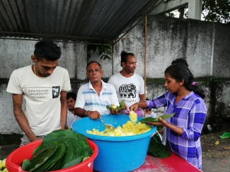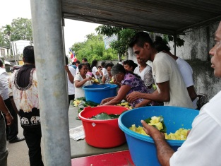

Cooked Manioc self- served by everybody as a meal at ‘DAN SALA’

**‘POSON BHAKTHI GEE’ PROGRAM**

Organized and conducted by ‘LANKA ASSOCIATION’ , this year ‘Poson Bakthi Gee’ program was staged on 22nd June 2018 at the venue of ‘SUMAGA Training Centre’, Mt. Lavinia. Our children joined this program for the first time but they have got a real novel experience.

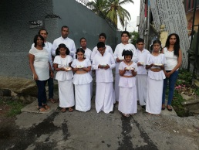

POSON BHAKTHI GEE TEAM REHERSING

FOR THE STAGE SHOW

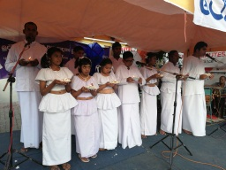

Poson Bakhthi gee

SQUaD PERFORMING

On the stage

**ART & HANDICRAFT EXHIBITION**

O

n 24th Oct.2018 the Art & Craft Exhibition was held at the venue of ‘Raja Maha Viharaya’, Kelaniya. It was opened at10 a.m. and a large number of people joined and participated. Especially the children and adults of the’ ***Preethipura Adults and children’s Home’*** were engaged and co-operate with us to sell a number of handmade items of our children.

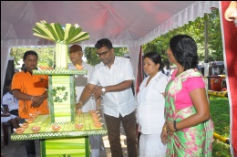A number of spectators, exceeding 3000 had come to see the Exhibition, and most of them bought something, praising the excellent quality, and to show their interest in giving their hands to build up the courage and the born skills of our children.

***Inauguration of the exhibition by the Chief Guests at the venue, Raja maha Viharaya, Kelaniya.***

***Hand paints and the arts made by our children were appreciated by the visitors.***

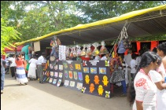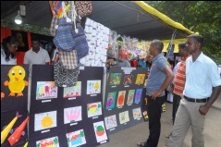

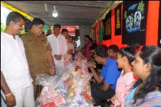

***The Guests were buying***

***items at the stalls***

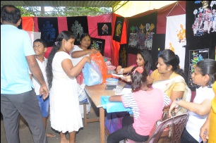***The visitors were very busy at the STALLS,***

***selecting the items in according to their desires*.**

**creative activities of children to boost their artistic taste gave this opportunity to keep alive with actual cheerfulness and their creations shown at the exhibition appreciated to gave them some value.**

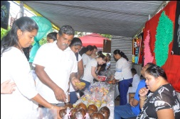

***Parents too wanted to buy something to encourage their children*.**

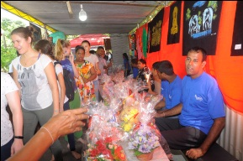

***Even Foreigners were interesting at the***

***handmade Crafts at the exhibition***

.

**NATIONAL PARA-OLYMPIC COMPETITION**

Some of our children were involved this time in Multi-Sport events at the National Para-Olympic Competition on 20th & 21stJuly 2018. Our children were able to win 2 Gold medals and a Silver Medal.

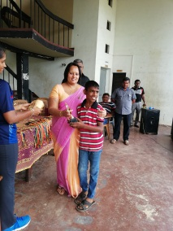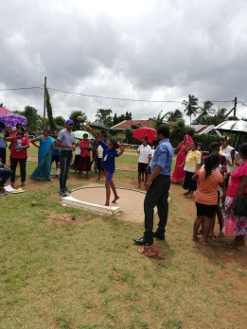

***winning***

***trophies***

***Throwing***

***putt***

***shot***

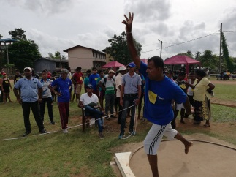

***Throwing***

***putt***

***shot***

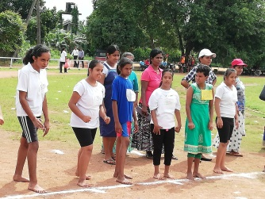***WAITING ANXIOUSLY for the***

***start of the race***

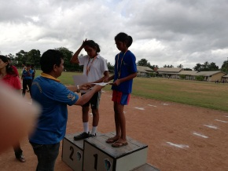

***winning the 1st place***

**Entertainment in and around’ Western Province Cultural competition’**

On 28th July 2018 the cultural show of the western province of Sri Lanka was held. Our children won places in several events at the competition.

The great victories gained by ‘SERD’ fellows are as follows,

* Hand craft creations of mentally retarded children (over 18 years of age)

**Won the 1st place & 2nd place**.

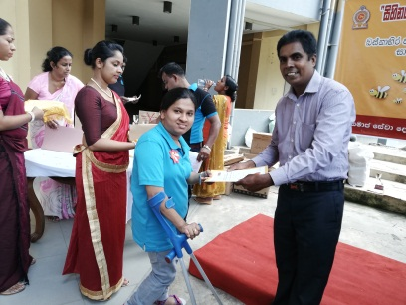

* Competition of physically disabled children 0ver 18 years

**Won the 2nd place**.

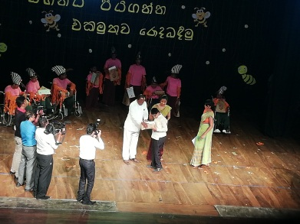

* 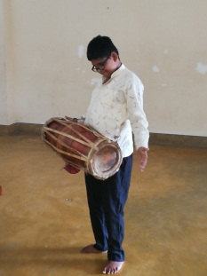Playing solos of local drums.

**Won the 1st place**.

* Competition of singing folk songs

**Won the 1st place**

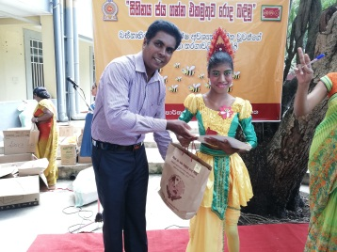

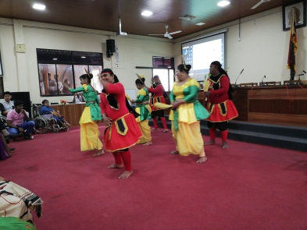

* On 6th December 2018 to show our children’s

skills In dancing we created dancing item for the

ceremony of disable children of Gampaha District, and we are

the only one who performed at this ceremony

from Kelaniya Provincial Secretariat Division.

* 15 children of ‘SERD’ with their parents joined the ceremony of specially needed children held on 18th December 2018 they were performed 4 items on this day.

**The world children’s day**

F

or the participation a number of sport events were introduced by the organizers. Our children participated and enjoyed the day with a lot of happiness and for each & every child a present has been offered by the organizing committee.

Universal children’s Day has celebrated with the co-operation of 2nd year students of the University of Colombo.

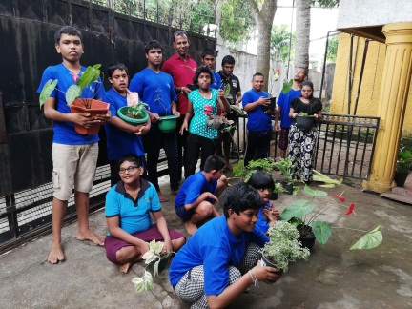

***Plant Growing campaign started on World’s Children Day***

**.**

**A visit to ‘PLEASURE ISLAND HOLIDAY HOME’ --DAMBULLA**

All the children with some of their parents were joined the trip to visit ***Dambulla, ‘Pleasure Island Holiday Resort’*** with a lot of experiences.

The children participated had a thrilling experience of travelling in a boat. However, it brought the pleasure with a novel experience in a boat trip. They had their meals at the Pleasure Island. They sang and dance to show their happiness and all of the children with the parents enjoyed the trip utmost, for their satisfaction.

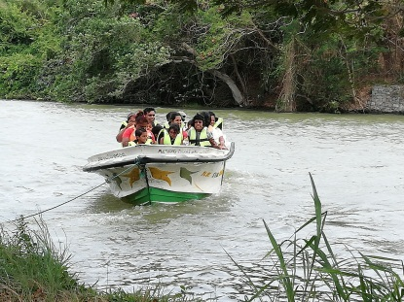

***Novel experience of riding in a boat***

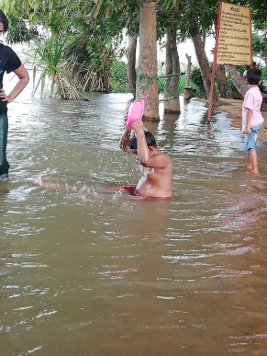

***BATHING***

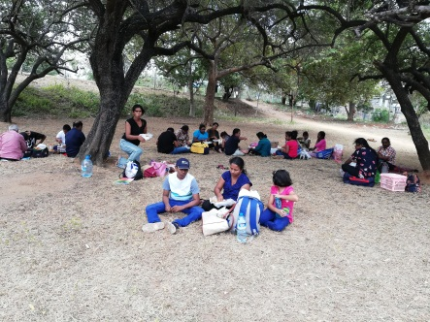 ***IN THE***

***RIVER***

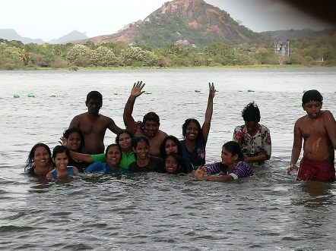

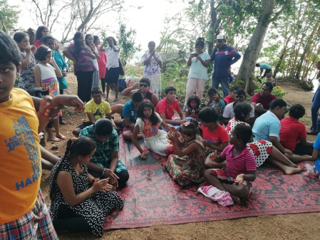

***ENJOYED THE TRIP***

***(Singing and dancing)***

**Medical Clinic**

A walk in medical clinic was introduced on 9th & 10th of June 2018 (including both days), because we believe that health is a fundamental human right of each and every child, and after examine, medical treatments have given, when and where there is the necessity.

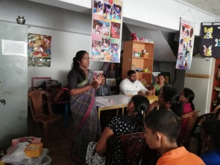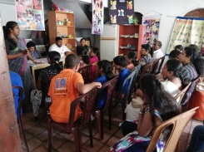

***Examining children for medical treatments***

**Sharing the knowledge of nutritional needs**

Knowledge sharing seminar is organized for teachers on 24th Jan 2018, with the co-operation of Hope for Children on daily dietary supplements of the needy children, dietary supplements include vitamins, minerals, herbals can also effect on the health of the children. So it’s very important to learn or having the knowledge on the role of the human food supplication. On this purpose the bureaucrat of the Kelaniya Provincial Secretariat Division joined with us.



**Sahan Eliya Program**

On24th Nov 2018 the ‘SAHAN ELIYA PROGRAMME’ was staged at the ‘Cultural Centre of the Western Provincial Division.

Our children had participated with the ‘Sahan Eliya Programme’ and well performed producing the dancing item ‘Dandanatha vara Natuma’.

23 institutions had competed at the ‘SAHAN ELIYA PROGRAMME’.

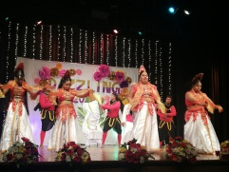

***Scenes from ‘Dandanatha***

***Vara Natuma’***

***the dancing item***

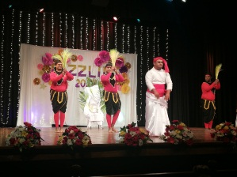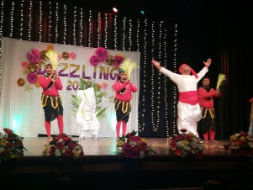

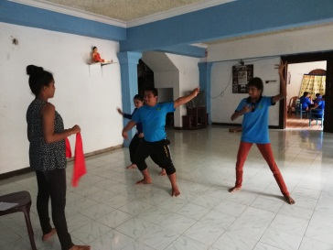

On 22nd December 2018 we celebrated Christmas with our children to let them understand value of living in co-operation with our neighbors. This time the whole program has organized by us with Carols and Dramas of Christianity. The gifts were distributed among all children.

***Christmas Festival***

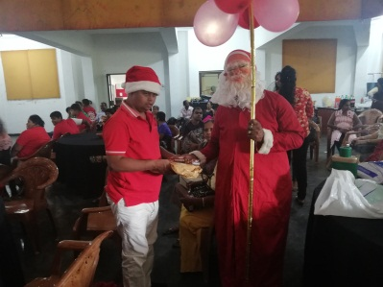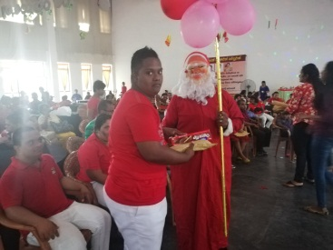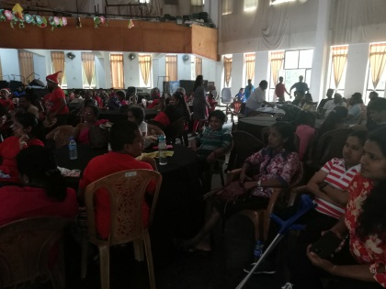

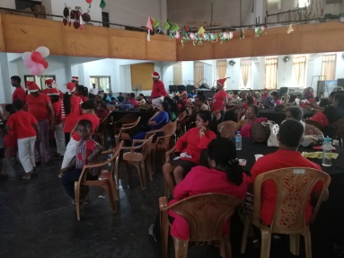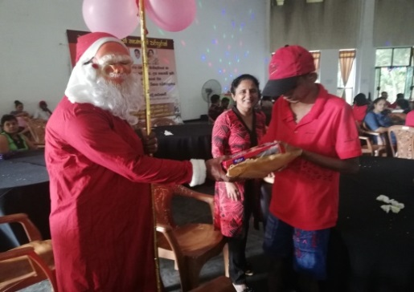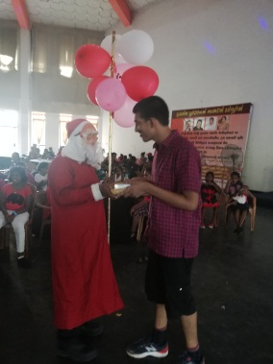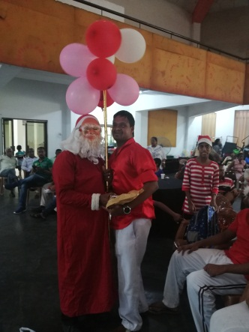

On 23rd Dec 2018, we were invited by the ‘blossom’ pre - school to perform a dance and a song, for the stage show which was staged at the tower hall theatre.

***Invited programme***

Our children were able to surprise the all spectators at that musical show.

Our Children forwarded the dance of ‘Dandanatha Vara’ and ‘Savindu Mihiranga one of our students had sung a song.